**USING RAPTOR – DISPLAY POSITION OF NUMBERS**

**FLOWCHART**

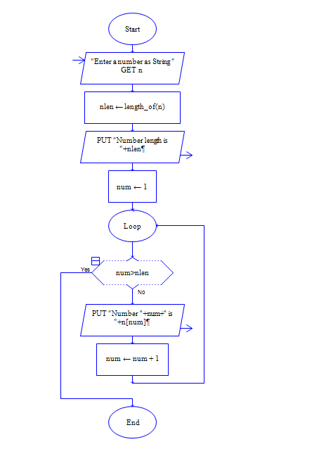

**OUTPUT**

INPUT IS VISHNU079

